This game is kind of tutorial and kind of game on how to install java, some basics of command prompt, java file compilation and run on Windows 10.

*Probably this method will work on older versions of Windows also.*

1. Install java jdk **if don’t have one** on your system. You can check some YouTube videos by typing “how to install jdk”. This one for example: <https://www.youtube.com/watch?v=Wp6uS7CmivE&t=302s>

Or you can use my brief instruction below:

1.1. Go to this <http://www.oracle.com/technetwork/java/javase/downloads/jdk8-downloads-2133151.html> official Oracle page to download Java. Accept License Agreement, choose appropriate version for you and download file then.

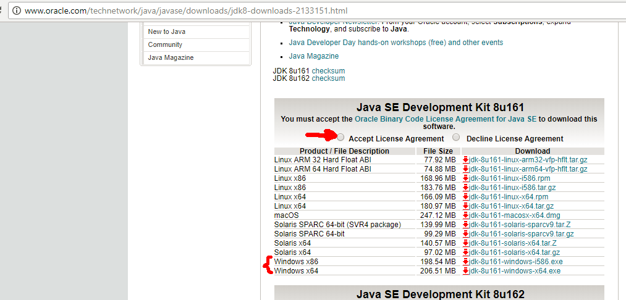

1.2. Run that previously downloaded file and follow the instruction of installer. You can leave default options, but remember jdk installation path. Wait a sec. for installation process…

1.3. Next you have to set environment variables on your system:

Right-click on “**My Computer**” -> “**Properties**” -> “**Advanced system settings**” (on the top-left) -> “**Environment Variables…**” button on the bottom -> double-click on “**Path**” of “System variables” part of form. -> “**New**”-> paste paths for jdk and jre “bin” folder (for example: C:\Program Files\Java\jdk1.8.0_161\bin, and then: C:\Program Files\Java\jre1.8.0_161\bin).

You also have to set “**JAVA_HOME**” environment variable. To do that go to “System variables” form -> click “New“ -> enter “JAVA_HOME” for “Variable name:” and “path/to/jdk” for “Variable value:” (for example: C:\Program Files\Java\jre1.8.0_161).

That’s it, we done with Java installation. Test time ☺

Go to Command Prompt and type “javac -help”. “Start” -> type “cmd” -> click on “Command prompt” -> type “javac -help” -> press Enter. If there is a list of options – Congratulations! Now you’ve got Java on your machine.

2. To play game go to directory where you downloaded “Game.java” file.

In order to do that, go to **Command Prompt** (“Start” -> type “cmd” -> click on “Command prompt”).

Then type “cd path/to/Game.java” (you can copy that path from Windows Explorer) -> click “Enter”

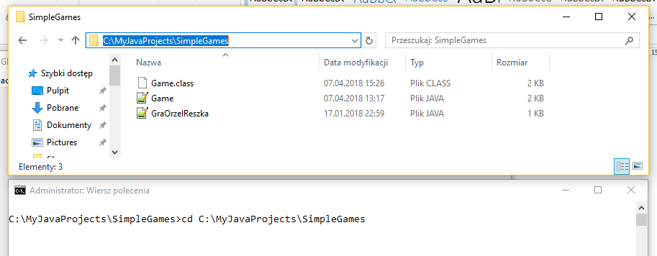

Now you in out game directory.

}} Compile “Game.java” file by typing “javac Game.java”, after that you’ll see compiled Game.class file inside our folder.

}} Run game by typing “java Game” (main method of Game.class)

}} Follow the instructions on Command Prompt and have a little bit of fun by trying to guess what word you have to enter. You can make only 4 mistakes.

Now play around with code like this sly fox ;)



Try to see the code and figure out why this game works this way.